Laboratory work on discipline
"Plant Physiology"
Title Subject: Physiology of plant cells. water metabolism
Lab. work 8. Effect of anion and cation salts on the form and time of plasmolysis
Purpose: To observe the effect of anion and cation salts on the form and time of plasmolysis.
Assignments:
1. Make a cut from the convex surface of the epidermis of colored onion.
2. Plasmolysis observe under a microscope by various salts.
Guidelines: A slice of the epidermis with the convex surface of the color onion are placed in a drop of the test solution of salt, cover with a coverslip and examined under a microscope. Watch the changing forms of plasmolysis. Determine the time of plasmolysis in each salt.
The results are recorded in the table.
Table
№ | Salt | Concentration | Time putting | Time of beginning of convex plasmolysis | Time of plasmolysis,  min
 | 1 Ca (NO3)₂ | 0,7 M
2 | KNO₃ | 1 M
3 | KCNS | 1 M

Title Subject: Physiology of plant cells. water metabolism
Lab. Work 9. Observing the cap plasmolysis
Purpose: Observing the cap plasmolysis
Assignments:
1. Make a cut from the convex surface of the epidermis scales of colored onion.
2. Place the cut in a drop of 1 M solution KSCN. Observe under a microscope.
Guidelines. Make a cut from the convex surface of the epidermis of colored onion, placed on a glass slide in a drop of 1 M solution of KSCN and cover with a cover glass. Sketched a single cell with a distinct cap plasmolysis. Write a conclusion.
Types of plasmolysis
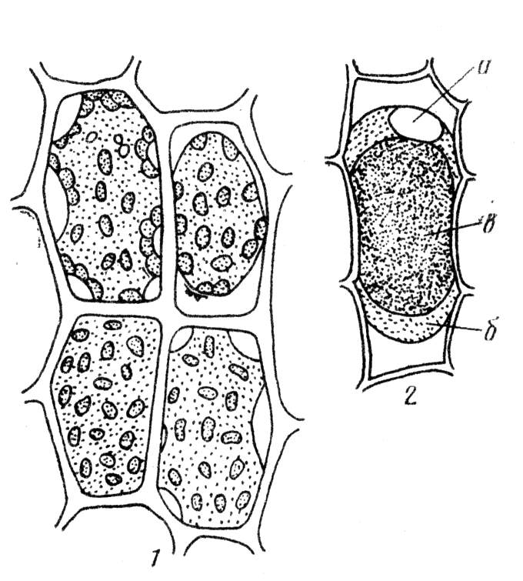
б
а
1 - Successive stages of plasmolysis in leaf cells of moss: a - Chevron (уголковый) plasmolysis, b - convex (выпуклый) plasmolysis.
2 - cells of the epidermis of onion scales with colored anthocyanin vacuole, -cap plasmolysis: a - nuclear, б – cytoplasm, в - the vacuole.

Title Subject: Physiology of plant cells. water metabolism
Lab. Work 10. Changes in the permeability of the cytoplasm under damage.
Purpose: Determination of potential osmotic pressure of the cell sap by method of plasmolysis. To determine the potential osmotic pressure of the cell sap by plasmolysis. Changes in the permeability of the cytoplasm under damage.
Assignments:
1. To prepare the solutions of different concentrations to obtain an isotonic solution.
2. To make a cut from the convex surface of the epidermis scales (чешуи) colored onion.
3. To place the slices in solutions with different salt concentrations.
4. To observe plasmolysis and calculate the potential osmotic pressure.
Guidelines. In preparing beaker 10 ml of 0.7 M, 0.6 M, 0.5 M, 0.4 M, 0.3 M, 0.2 M sucrose solution are prepared by diluting a 1 M solution of dist. water. To make the cut with a convex surface of the epidermis scales colored onion by blade, 2-3 slice are placed in a beaker. After 30 minutes, the slices were examined under a microscope. Determine the degree of plasmolysis cells in each solution and are isotonic concentration as the arithmetic mean of the concentrations at which plasmolysis just beginning and that at which plasmolysis does not observe.
Write in the table.
Concentration of sucrose, М | On 10 мл solution |  | Time of duration of tissue in the solutions |  | degree of plasmolysis | isotonic concentration | potential osmotic pressure of the cell sap
Concentration of sucrose, М | 1М sucrose | Н₂О, ml | Time of putting | time of observation | degree of plasmolysis | isotonic concentration | potential osmotic pressure of the cell sap
0,7 | 7 | 3
0,6 | 6 | 4
0,5 | 5 | 5
0,4 | 4 | 6
0,3 | 3 | 7
0,2 | 2 | 8

П=RxTxCxIх101,3, where
R-gas constant: 0.0821 atm/gradhmol; T-absolute temperature (273⁰S + room temp); C - isotonic concentration in moles; I - isotonic coefficient Vant-Hoff, 101.3 - factor to convert atmospheres in kilopascals. Write a conclusion.

Topic: Photosynthesis.
Lab. Work 11. Extraction of leaf pigments. Photosensitizing effect of chlorophyll on the reaction of hydrogen transfer. Alkaline saponification of chlorophyll.
Objective: To obtain an alcoholic extract of green leaf pigments.
Assignments:
1. To obtain an alcoholic extract pigments sheet.
Guidelines.
1. 1-2 g of leaves placed in a porcelain mortar, crush, add a little calcium carbonate or quartz sand and pounded. 4-5 ml of ethyl alcohol pour to his mass and then rubbed. After settling, the underside of the spout mortar lightly greased with Vaseline, and the green solution was carefully poured into a glass funnel with a paper filter.
The filtrate was transferred to a volumetric flask of 10 ml, the content of flask adjust to the mark with the solvent, cover the rubber stopper and shake thoroughly.
2. Separation of pigments by Kraus method.
Guidelines. In the test tube pour 2 ml of alcoholic solution of the extract of pigments and add 3-4 ml of gasoline. Contents of the tube is shaken strongly pre-closed hole. Gasoline emulsion layer will turn green because gasoline better solute chlorophyll then alcohol.
Carotene passes in petrol, but paint is masked by chlorophyll. Xanthophyll remains in the alcohol layer, giving a golden yellow color.
Draw the picture of the distribution of individual pigments.
Write a conclusion on lab. Work.
Purpose: To observe saponification of chlorophyll by adding of alkali.
Assignments:
1. In the test tube with separated by Kraus green leaf pigments add alkali and observe the saponification of chlorophyll by alkali.
Guidelines. In the test tube with pigments separated by Kraus method add dry alkali. Shake and boil. After boiling, the tube cooled. To the cooled solution an equal volume of gasoline and a few drops of water are added. The contents are then shaken and allowed to settle. Carotene and xanthophylls will move in the gasoline layer and sodium salt of chlorophyll acid will move in the alcoholic solution -.
COOC₂₀H₃₉ COONa
MgN_{4O}H₃₀C₃₂ +2NaOH → MgN₄OH₃₀C₃₂ + C₂₀H₃₉OH + CH₃OH
COOCH₃ COONa

Topic: Photosynthesis.
Lab. Work 12. Quantitative determination of chemical properties of leaf pigments.
Photosensitizing effect of chlorophyll on the reaction of hydrogen transfer by Gurevich
Purpose: To quantity the leaf pigments, observe the photosensitizing effect of chlorophyll on the reaction of hydrogen transfer.
1. Guidelines. Take 4 test tubes:
in the number of 1, 2.3 and 5 ml pour alcohol extraction of chlorophyll,
the 4th - 5 ml of ethanol.
In the number of 1, 2 and 4th tubes add 50 mg crystalline ascorbic acid and solution shaken.
In all tubes with chlorophyll alcoholic solution of methyl red are added br drops until the green color will change to red-brown.
In the 4th test tube color adjusted with methyl blue to bright pink.
Second tube is closed cover of black paper, then all the tubes are illuminated. A water-filled vessel is placed between the tubes and the light source.
After 10-15 minutes of lighting in the 1st test tube methyl red becomes colorless due to recovery and the solution is green. In test tubes color of the solution does not change, because the lack of light, ascorbic acid or chlorophyll methyl red is not restored leucoagent.
Fill the results of lab. work in the table
Variant | The mixture in the test tubes |  |  | Conditions of experiment | Results
 | Chlorophyl, ml | Ethanol | Saturated alcohol solution of methyl red | Conditions of experiment | Results

Draw a conclusion of lab. work.

Topic: Photosynthesis
Lab. Work 13. Determination of the rate of photosynthesis by assimilation flask.
Objective: To determine the rate of photosynthesis by assimilation flask.
Tasks: Identify the rate of photosynthesis by assimilation flask.
Guidelines. Take 2 bottles and wrap their throat pieces of paper.
Stand the flask for 20-30 minutes to fill with air.
Then simultaneously insert tube with holes, closed with glass stoppers.
Cut off a branch, update razor cut under water and place in a water-filled tube attached to a stick inserted into the cork.
Expose to the light bulb.
Duration of the experiment should be such that the leaves do not have time to absorb more than 25% carbon dioxide content.
Fill the results in the table
Sheet No. Ba(OH) 2 Number of HCl, Jr. Amendment titer Int Th f / s.

Objects Объекты | Time |  |  | Square of leaf | Amount of Ba(OH)2 | Amount of НCl, ml |  | Amendment titer Int | Photosynthesis intensity
Objects Объекты | Start | End | Duration | Square of leaf | Amount of Ba(OH)2 | experience | control | Amendment titer Int | Photosynthesis intensity
Write the results as conclusion of lab. work

Topic: Plants respiration
Lab. Work 13. Determination of the respiration of seeds in a closed vessel.
Objective: To determine the intensity of the respiration of seeds in a closed vessel.
Tasks: Identify the respiration of seeds in a closed vessel.
Guidelines. The method consists in accounting for the amount of CO2 released by seed respiration, CO2 is absorbed by barite.
Ba(OH)₂ + CO₂ + H₂O → BaSO₃.
Excess barite, not react with CO₂ is titrated with oxalic acid.
Ba(OH)₂ + H₂ → BaS₂O₄ C2O4 + 2H₂O.
Guidelines.
4 g of germinated seeds of wheat or rice is placediIn gauze bag. In two conical flask is filled with 10 ml of 0.1 N Ba(OH)₂ and stoppered.
In one flask, opening quickly append a bag of seeds, add 3 drops of phenolphthalein and titrated with 0.1 N barite oxalic acid to slightly pink color. Titrated as barite in the control flask. In the titration flask stopper through which the tip of the pipette attached to the bottle with barite.
Respiration rate (mg CO₂ allocated 1 g of dry seeds for 1 hour:
I = (a-b): kx2, 2 n,
where a and b - the number of 0.1 N oxalic acid at a cost of tirovanie barite, respectively, in the control and experimental flask, ml.7
For the correction to the titer.
2.2 - the amount of CO2 matching 1 ml of 0.1 N oxalic acid,
n - mass of dry seeds
Fill the results in the table
Experimental conditions | Weight of seed g | seed moisture,% | dry weight of seeds, g | Volume barite ml | Amounts of oxalic acid, ml |  | respiration intensity mg CO2 / g dry seeds
 |  |  |  |  | control | experience | respiration intensity mg CO2 / g dry seeds

Write the results as conclusion.

Topic: Plants respiration
Lab. Work. 13. Determiantion of dehydrogenases in plants recovery of methylene blue
Explanations: Dehydrogenase. Enzymes of this group is oxidized substrate by withdrawal of hydrogen. This group of enzymes oxidizes a wide range of substrates. Coenzyme part dehydrogenase represente either pyridine nucleotides (NAD or NADP) or flavin nucleotides (FMN, FAD). Accordingly, different pyridine and flavin dehydrogenase are known.
Pyridine dehydrogenase enzymes are anaerobic, they are not able to transfer of reducing equivalents to oxygen. The redox potential of these dehydrogenases is - 0.32 V.
Tor NAD-dependent dehydrogenases lactate dehydrogenase, malate dehydrogenase, isocitrate dehydrogenase, the NADP-dependent glucose-6-phosphate dehydrogenase, 6-phosphogluconate dehydrogenase are included
Flavin dehydrogenase may be anaerobic, and aerobic. Oxidation with aerobic flavin dehydrogenase leads to the formation of hydrogen peroxide. These dehydrogenases may be called oxidases because of their interaction with oxygen.
Flavin Dehydrogenase have wide variety of oxidation-reduction potential, they often contain metals - copper, molybdenum, and iron.
The activity of the dehydrogenases can be determined as using methylene blue dye a hydrogen acceptor, which is recovered becomes a colorless leykoform:
C-H₂ + M C + M-H₂
Substrate oxidized methylene substrate reduced methyl blue

In contact with molecular oxygen leykoform methylene blue is spontaneously oxidized and regains color:
M - H2 + 1/2O2 -> M + H2O. Therefore, this experiment should be conducted without access to air.
Purpose of lab. work: Determiantion of dehydrogenases in germinating seeds of peas on the rate of recovery of methylene blue as a function of temperature
Objective germinating seeds of peas or beans, (roots no longer than 0.5 cm).
Reagents: a solution of methylene blue (50 mg/l), distilled water.
Scheme of work:
1. Seeds of peas + methylene blue at room temperature.
2. Seeds of + methylene blue at 30 ° C.
Guidelines.
To peel 10-12 germinating seeds of peas and split them into cotyledons. Half of the plant material placed in a flask with water and boil for 3 minutes to destroy enzymes.
Number the 4 tubes, 1 and 3 put boiled germinating seeds of peas,
2 and 4 normal seeds.
To pour 5 ml of methylene blue in all the tubes with.
After 5-10 minutes, when the cotyledons heavily stained, pour the dye solution.
Thoroughly rinse the plant material with water,
To fill all test tube to the brim with distilled water and close the caps.
Put 1 and 2nd tubes in water bath at 30 ° C.
3 and 4th left in room conditions.
Research results are entered into the table. 1,
Write the results as conclusions in the table.
Tab. 1. Effect of temperature on the activity of the dehydrogenases
Objects of study | Experience (incubation temperature) | Intensity of the color of cotyledons
1. Peas | 20 ºC
 | 30 ºC

Topic: Plants respiration
Lab. work 13. Determination of peroxidase in the juice of potatoes
Explanations: Peroxidase - enzymes that oxidize the substrate with hydrogen peroxide. The reaction:
H₂O₂ + AH₂ -> A ₂ H₂O ,
where A and AH2 - oxidized and reduced substrate, respectively.
Peroxidase substrates are phenols and aromatic compounds, organic hydroperoxide with small aliphatic substituents, NADH (NADPH), naphtohydokhinon, indoleacetic acid, etc.
Peroxidase are - iron enzymes, prosthetic group is a gem - ferriprotoporfirin IX.
Hydrogen peroxide is formed in the cell as a by-product of the catalytic activity of flavin dehydrogenases in the electron transport chain of respiration. Consequently, the activity of peroxidase disposal of toxic hydrogen peroxide to cells and indirectly associated with the work of the main respiratory ETC.
At the same timeit is found that the peroxidase is able to function as a typical oxidase catalyzes the oxidation of the substrate oxygen:
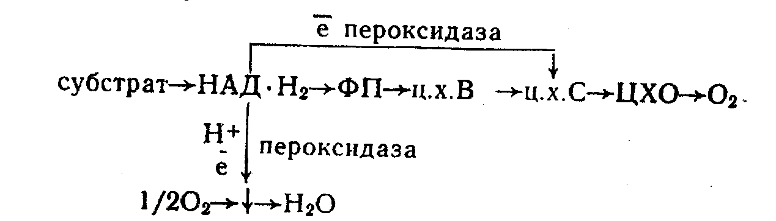
Thus, peroxidase, on the one hand, can oxidize NAD-H₂ by air oxygen, on the other - to transfer electrons derived from NAD-H₂ to the various acceptors (eg, cytochrome c). In both cases, the peroxidase is a link of ETC respiration.Oxidation of substrates is by the one-electron mechanism.
The first step of the catalytic process is the formation of a complex between the iron-enzyme and hydrogen peroxide. Therefore, substrate is oxidated by hydrogen peroxide activated enzyme:

Е-Н₂0 + 2Н₂0₂ -> Е-Н₂0₂ +Н₂0
Соединение 1
Е-Н₂О + Н₂О₂ → Е - Соединение 2 + АН
Compound 2 + АН →Е - Н₂О + А
Compound 1 - oxidized form of the enzyme, where the iron is bound to the peroxide and the valence state of Fe higher Fe3 +;
compound 2 - product reduction of compound 7 by one-electron reduction by substrate AH₂, AH₂. . substrate reaction, free radical AN-oxidized form of the substrate, and A-product of complete oxidation of the substrate.
Peroxidase determination is based on the formation of colored products in the oxidation of benzidine, guaiacol, hydroquinone, catechol, and other phenols. In this study as an indicator for the detection of peroxidase used hydrokhinone. Oxidation of polyphenols to quinones is the scheme:

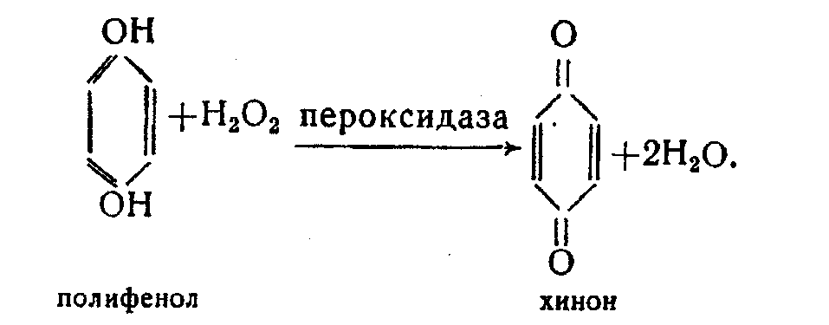
Objective: to establish the presence of peroxidases in potato tubers, apples.
Objects of study, reagents and equipment.
Objects of research: potato tuber, apple.
Reagents - solutions: 1% hydroquinone, 3% hydrogen peroxide.
Equipment: knife, grater, gauze, funnel, conical cone for 50 ml tubes in racks, pipette 1 and 10 ml.
Study design is shown in Table. 1.
Tab. 1. The effect of high temperature on the activity of the enzyme peroxidase
Variant | The mixture in the test tube |  |  | color of the solution in a test tube
Variant | Potato juice (medium peroxidase) | Н₂О₂ | hydroquinone | color of the solution in a test tube
1 | + | + | +
2 | - | + | +
3 | + | - | +
4 | + (after boiling | + | +
Procedure
Grate some mash potato tuber or peeled apple squeeze out the juice through cheesecloth and collected in a flask. Prepare four tubes and add to them n 5 ml of a 1% solution of hydroquinone.
In a test tube 1 ml of 3% hydrogen peroxide and 1 ml of potato juice are added,
In II tuve -1 ml of 3% hydrogen peroxide solution,
In the III - 1 ml of potato juice
Iin the IV - 1 ml of potato juice preliminary boiled for one minute and 1 ml of H₂O₂.
In the oxidation of hydroquinone to quinone is browning solution. Some browning of potato juice is observed without the addition of hydroquinone and hydrogen peroxide to it. This is due to the action of polyphenol oxidase, oxidized polyphenols potato tissue with molecular oxygen.
Note the color in the test tube and explain the experimental results, which are recorded in Table. 1.
Based on the data in Table. 1 Write conclusions.

Topic: Mineral nutrition.
Lab. work 14. Micro chemical analysis of ash.
Objective: To carry out microchemical analysis of ash.
Procedure To microchemical analysis of ash.
Guidelines. Put into a test tube a small amount of ash and fill it 4-fold volume of 10% HCl. To filter the solution into a clean test tube. Hold on glass reaction of Ca, Mg, P. To do this, the blunt end of a glass rod put on a glass slide a drop of extract and at a distance of 4-5 mm from drop of extract the drop of the appropriate reagent.
Then connect two drops by using arcuate channel. There will be a crystallization of the reaction products.
Reagent for Ca is 1% H₂SO₄. This Ca chloride contained in the extract reacts to the acid of the equation.
CaCl₂ + H₂SO₄ → CaSO₄ + 2HCl
Gypsum is released in the form of needles.
For Mg add a drop of ammonia solution, then combine this solution with the reagent - 1% solution of sodium phosphate. The phospho ammonia magnesium salt. Is formed
MgCl₂ + Na₂HPO₄ → NH₄MgPO₄ + 2NaCl
For P - 1% solution of ammonium molybdate in nitric acid. The green yellow precipitate of phospho molybdate ammonium salt is formed .
N₃PO4 + 12 (NH₄) 2 MoO₄ + 21 HNO3 → (NH₄) 3PO4 + 2 MoO₃ + 21 (NH4) NO₃ +12 H₂O
FeCl₃ + 3K₄ (Fe (CN) 6) 2 → Fe₄ [(Fe (CN) ₆] 3 + 12 KCl
Write a conclusion. Draw the drugs.

Topic: Plants growth and development
Lab. Work 15. Dependence of seed imbibition from the composition of seeds under the absorption of water.
The necessary materials and reagents: the seeds of wheat and peas, technical scales, 2 Petri dishes, filter paper.
In case of contact to moisture seeds increases in volume due to proteins, starch and other hydrophilic colloids absorb water. This process is called imbibition. The reason is that these hydrophilic colloids absorb water are hydrated. Seed storage substances, especially proteins, have high hydrophilic properties. Process of protein hydratation consists of three processes:
1) electroneutral hydration - in a protein molecule hydrogen bonds (carboxyl, alcohol, amine, amide, etc. g.). form between polar groups of oxygen and nitrogen/
With such hydration temperature the seed increases along with an increase in. volume of seed,
2) The ion hydration - in a protein molecule ion group - COO "and NH3 + combine with water, pulling the dipole water molecules.
3) Hydration - immobilization of water molecules in the folded protein molecule remnants of free water.
Imbibition activates many biochemical reactions.
The main objective of this work: To prove dependence differences in swelling seeds of different species on the composition of store substances. In the composition of wheat seed protein is 16%, starch - 70%, and in peas seeds of 34% protein, starch - 48%.
Guidelines: In two separate petri dishes 3 g of wheat and peas are placed. Pour water before sinking seeds and leave for 1 hour or day (with decreasing water add water.) Then the water need to pour, the seeds are soaked filtr paper, and then weighed. The ratio of the final value seed weight is expressed to the initial seed weight as a percentage/

Fill the results the table.  Plant specie | Seed weight of the plants. gг |  | Change in seeds weight g
 | Before | After | Difference in Weight | The ratio of final weight to initial weight of seeds,%к
 | imbibition | imbibition
Peas
Wheat

Write the results as conclusion and answer on the following questions:
How is the swelling of the seed?
What does the swelling has the composition of seed storage substances?

Topic: Plants growth and development
Lab Work 15. Effect of indolile acetic acid (IAA) on shoots and roots growth of wheat.
Objective: To determine the effect of the IAA on shoots and root growth.
Tasks: To Identify the effect of IAA on shoots and roots growth.
Guidelines. 5 Petri dishes are lined with filter paper, moistened with 9 ml of water or a solution of the following concentrations of IAA: 0, .01, 0.001; 0.0001; 00001%.
To obtain the indicated concentrations of 1 ml of the 0.01% IAA is poured into a volumetric flask of 10 ml, and then is filled with water up to the mark, mixed and placed in Petri dishes . The remainder 1 ml of IAA solution is diluted with water.
On moist filter paper five grains of wheat are laid and closed by lid.
A week later, the length of roots and shoots is measured, conclude about delay of roots and shoots growth or its stimulation depending on the concentration of IAA.
Fill the results in the table.
Variant,  concentrations of IAA |  |  | length of roots, cm |  | length of shoots, cm |  | average length roots on 1 plant cm | Root length of variant to control,% | Shoot length of variant to control,%

